**Activitat 3 (No DUAL)**

Fes servir de base els programes ***Exemple3UrlConn*** (**CODI 3.1.4.2.5**) i ***isGifFormat*** (pdf continguts pàg.35) per crear un programa que:

1. Es cridi per línia d'ordres (faci servir els arguments de main)
2. Accepti com a entrada 3 paràmetres:
   1. Un argument tipus URL d'un lloc web.
   2. Un argument que digui el nombre de camps de capçalera que es vol mostrar.
   3. Un argument que sigui un text perquè mostri les línies de codi de la pàgina web que portin aquest patró.

Exemple: **#java cerca  http://insbaixcamp.org/  5  script**

Cerca a la web del Baix Camp i mostra 5 camps de la capçalera HTTP i tot el que hi ha al codi de la pàgina que porti el patró "script".

Heu de lliurar un pdf en format nomCognom.pdf on s'hi indiqui els membres del grup que heu realitzat l'activitat, la url del repositori del font en el núvol, el codi comentat de l'activitat i exemples de la seva execució, altrament no s'avaluarà.

**EQUIP**

Raúl Santos Espino

Tiffany Fernández Anguera

**REPOSITORI**

<https://github.com/TiffanyFA/M9UF3>

**EVIDÈNCIES**

Paràmetres:

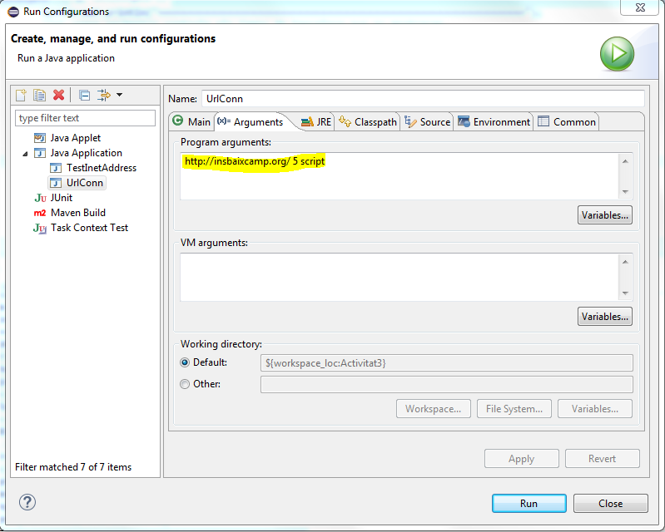

Exemple:

===============================================================

ADREÇA, DARA I CONTINGUT

Adreça [getURL]: http://insbaixcamp.org/

Data última modificació [getLastModified()]: Thu Nov 28 16:19:30 CET 2019

Tipus de Contingut [getContentType()]text/html; charset=utf-8

===============================================================

TOTS ELS CAMPS DE CAPÇALERA AMB getHeaderFields():

null:[HTTP/1.1 200 OK]

X-Microcache:[True]

Server:[nginx]

Connection:[keep-alive]

Last-Modified:[Thu, 28 Nov 2019 15:19:30 GMT]

Pragma:[no-cache]

P3P:[CP="NOI ADM DEV PSAi COM NAV OUR OTRo STP IND DEM"]

Date:[Thu, 28 Nov 2019 15:19:30 GMT]

Cache-Control:[no-store, no-cache, must-revalidate, post-check=0, pre-check=0]

Set-Cookie:[a90198802110d00f0f22860e790d8894=lv5qbc5mce7ml7b94bobvalrh0; path=/; HttpOnly]

Vary:[Accept-Encoding]

Expires:[Wed, 17 Aug 2005 00:00:00 GMT]

Content-Length:[58829]

Content-Type:[text/html; charset=utf-8]

===============================================================

Camps de Capçalera 5

getHeaderField(1)=> nginx

getHeaderField(2)=> Thu, 28 Nov 2019 15:19:30 GMT

getHeaderField(3)=> text/html; charset=utf-8

getHeaderField(4)=> 58829

getHeaderField(5)=> keep-alive

===============================================================

Contingut de [url.getFile()]: /

<link href="http://insbaixcamp.org/index.php/component/search/?Itemid=96&amp;format=opensearch" rel="search" title="Cercar INS Baix Camp" type="application/opensearchdescription+xml" />

<script src="/media/jui/js/jquery.min.js?77599e21abc75fcde085b32652383be0" type="text/javascript"></script>

<script src="/media/jui/js/jquery-noconflict.js?77599e21abc75fcde085b32652383be0" type="text/javascript"></script>

<script src="/media/jui/js/jquery-migrate.min.js?77599e21abc75fcde085b32652383be0" type="text/javascript"></script>

<script src="/cache/widgetkit/widgetkit-b7c508e2.js" type="text/javascript"></script>

<script src="/templates/tk_minimus_black/warp/libraries/jquery/jquery.js" type="text/javascript"></script>

<script type="text/javascript">

</script>

<script src="/templates/tk_minimus_black/warp/js/warp.js"></script>

<script src="/templates/tk_minimus_black/warp/js/responsive.js"></script>

<script src="/templates/tk_minimus_black/warp/js/accordionmenu.js"></script>

<script src="/templates/tk_minimus_black/warp/js/dropdownmenu.js"></script>

<script src="/templates/tk_minimus_black/js/template.js"></script>

<ul class="nav-child unstyled small level3"><li class="level3 item279"><a href="https://drive.google.com/file/d/1lZGp9eq-OZAZD3SqmLLquxWn1geugo1k/view?usp=sharing" target="_blank" rel="noopener noreferrer" class="level3"><span>PEC (Projecte Educatiu de Centre)</span></a></li><li class="level3 item331"><a href="https://drive.google.com/file/d/1I7-WbM9c6HKQBdh1CGPT58Ck48V9M-gM/view?usp=sharing" class="level3"><span>NOFC (Normes d'OrganitzaciÃ³ i Funcionament de Centre)</span></a></li><li class="level3 item311"><a href="https://drive.google.com/file/d/1-PF-eL0l9kdvwrRtx4aJKx2on-nPq53m/view?usp=sharing" target="_blank" rel="noopener noreferrer" class="level3"><span>PLC (Projecte LingÃ¼Ã­stic de Centre)</span></a></li><li class="level3 item338"><a href="https://drive.google.com/file/d/1lZGp9eq-OZAZD3SqmLLquxWn1geugo1k/view?usp=sharing" target="_blank" rel="noopener noreferrer" class="level3"><span>Carta de compromÃ­s educatiu ESO/Batx</span></a></li><li class="level3 item339"><a href="https://drive.google.com/file/d/1463sU_aHJtNA1cmBu1e4yaSl-GIFg_1B/view?usp=sharing" target="_blank" rel="noopener noreferrer" class="level3"><span>Carta de compromÃ­s educatiu CF</span></a></li><li class="level3 item336"><a href="https://drive.google.com/file/d/1pzhC7QYnxKdRBcIlneSzsP7KbM8CMEHY/view?usp=sharing" target="_blank" rel="noopener noreferrer" class="level3"><span>Pla TAC</span></a></li><li class="level3 item340"><a href="https://drive.google.com/file/d/1He2v4lSnfHYKnQN9UG61uzMABw-2elkx/view?usp=sharing" target="_blank" rel="noopener noreferrer" class="level3"><span>Projecte de convivÃ¨ncia</span></a></li></ul></li></ul></div></div></div></div></li><li class="level1 item131 parent"><a href="/index.php/oferta-d-estudis" class="level1 parent"><span>Estudis</span></a><div class="dropdown columns1"><div class="dropdown-bg"><div><div class="width100 column"><ul class="nav-child unstyled small level2"><li class="level2 item164"><a href="/index.php/oferta-d-estudis/eso-i-batxillerat" class="level2"><span>ESO i Batxillerat</span></a></li><li class="level2 item165 parent"><a href="/index.php/oferta-d-estudis/cicles-formatius" class="level2 parent"><span>Cicles Formatius</span></a><ul class="nav-child unstyled small level3"><li class="level3 item166"><a href="/index.php/oferta-d-estudis/cicles-formatius/cf-de-grau-mitja" class="level3"><span>CF de Grau MitjÃ </span></a></li><li class="level3 item167"><a href="/index.php/oferta-d-estudis/cicles-formatius/cf-de-grau-mitja-2" class="level3"><span>CF de Grau Superior</span></a></li></ul></li></ul></div></div></div></div></li><li class="level1 item132 parent"><a href="/index.php/secretaria-i-tramits" class="level1 parent"><span>Secretaria</span></a><div class="dropdown columns1"><div class="dropdown-bg"><div><div class="width100 column"><ul class="nav-child unstyled small level2"><li class="level2 item160"><a href="/index.php/secretaria-i-tramits/proves" class="level2"><span>Proves</span></a></li><li class="level2 item161"><a href="/index.php/secretaria-i-tramits/beques" class="level2"><span>Beques</span></a></li><li class="level2 item162"><a href="/index.php/secretaria-i-tramits/altres-tramits" class="level2"><span>Altres trÃ mits</span></a></li><li class="level2 item199"><a href="/index.php/secretaria-i-tramits/altres-tramits-3" class="level2"><span>Calendaris</span></a></li><li class="level2 item198"><a href="/index.php/secretaria-i-tramits/altres-tramits-2" class="level2"><span>Formularis</span></a></li><li class="level2 item150"><a href="/index.php/secretaria-i-tramits/convalidacions-2" class="level2"><span>Convalidacions</span></a></li><li class="level2 item283"><a href="http://insbaixcamp.org/index.php/59-notes-de-secretaria/602-secretaria-tramits-preinscripcio-i-matricula-2017-18" class="level2"><span>PreinscripciÃ³ i MatrÃ­cula</span></a></li></ul></div></div></div></div></li><li class="level1 item170 parent"><span class="separator level1 parent"><span>Projectes</span></span>

<script type="text/javascript">

</script>

<script src="//translate.google.com/translate_a/element.js?cb=googleTranslateElementInit" type="text/javascript"></script></div>

<script src="/templates/tk_minimus_black/warp/js/search.js"></script>

<script>

</script>

<script>

})(window,document,'script','//www.google-analytics.com/analytics.js','ga');

</script>